Uclid Software VPN client setup

Windows 2000/Windows XP

To Set Up a Client for VPN Access
- Click Start, point to Settings, click Network and Dial-up Connections.
- Double-click Make New Connection, this will start the wizard, then click Next.
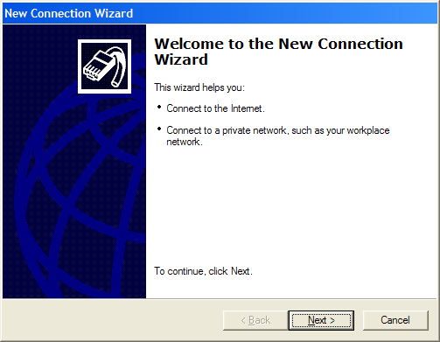
- Click Connect to the network at my workplace, and then click Next.
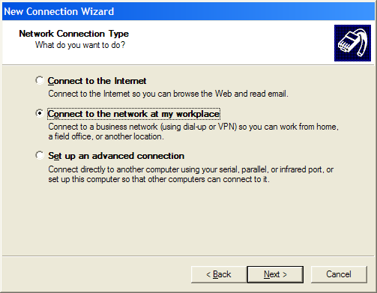

- Select Virtual Private Network connection on the next screen
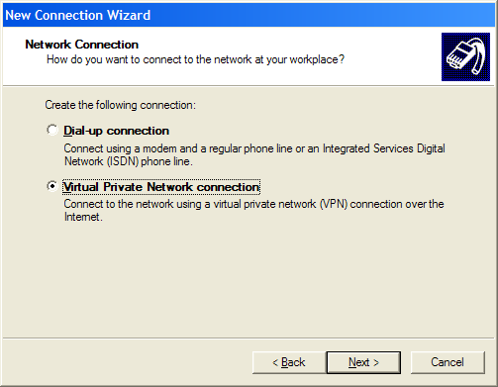
- Type in Uclid VPN in the Company Name field and click next.
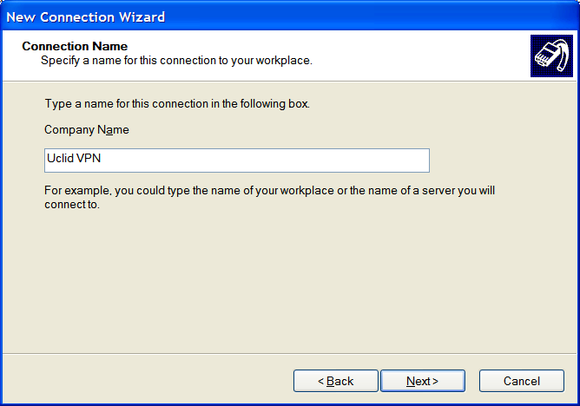
- If you need to use a modem to dial up and connect to the Internet, select Automatically dial this initial connection and the select your ISP connection from the drop down list.
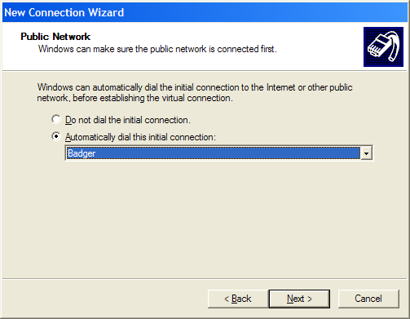
If you are always connected to the Internet with a DSL or Cable connection select Do not dial the initial connection.
Click next.
- Type the IP address of 66.170.12.157 in the Host name or IP address field and then click Next.
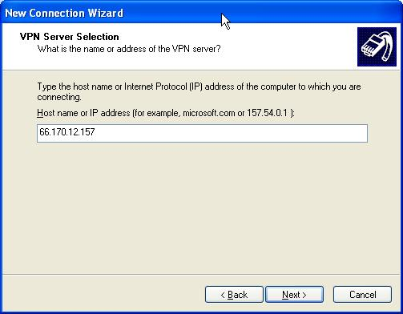
- Click one of the following options, and then click Next:
  - If you want to allow any user that logs on to this workstation to use this VPN connection, click For all users.
  - If you want this connection to be available only to the currently logged-on user, click Only for myself.
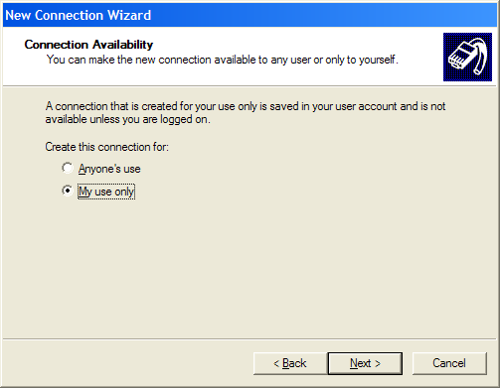
- Click the box to Add a shortcut to this connection to my desktop and click finish.
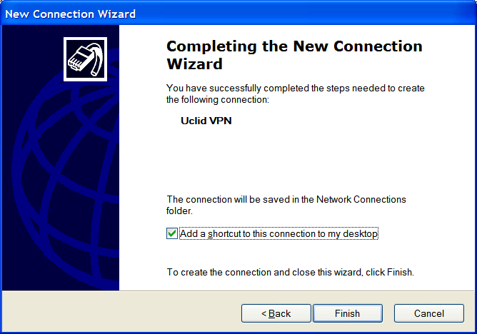

You’re connection to the Uclid network is now setup.

To Connect to the Server
- Double-click the newly-created VPN connection shortcut on your desktop.
- In User Name, type uclid-vpn (Everyone will use this User name).
- In Password, type the password for the VPN user, and then click Connect.
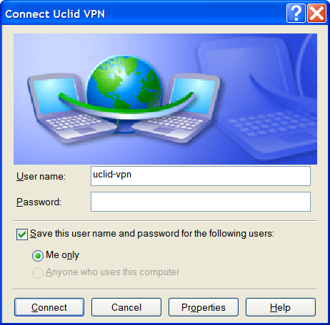

After a few moments you will be connected and a small icon will appear in the taskbar down by the clock.

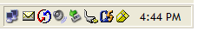

Once connected you should be able to browse for network resources in My Network Places. If there is a conflict with the remote computers browsing service, many times you can access a server’s resources by going to Start --> Run and typing in the server name.

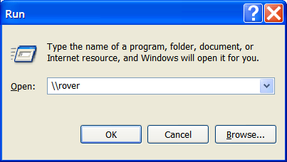

To disconnect from the VPN

- Double click the connection icon on the taskbar.

- Click the disconnect button.

